Core Workflow Diagram
Basic workflow with mandatory (M) and suggested (S) modules.
- StarTools workflow allows some flexibility. The diagram is not meant to show a fixed flow but to help beginners putting the moduls in a meaningful order.
- Within 'Tracking On' block, StarTools allows the execution of steps in a different order
- Loading, stretching and noise reduction steps offer two options each.
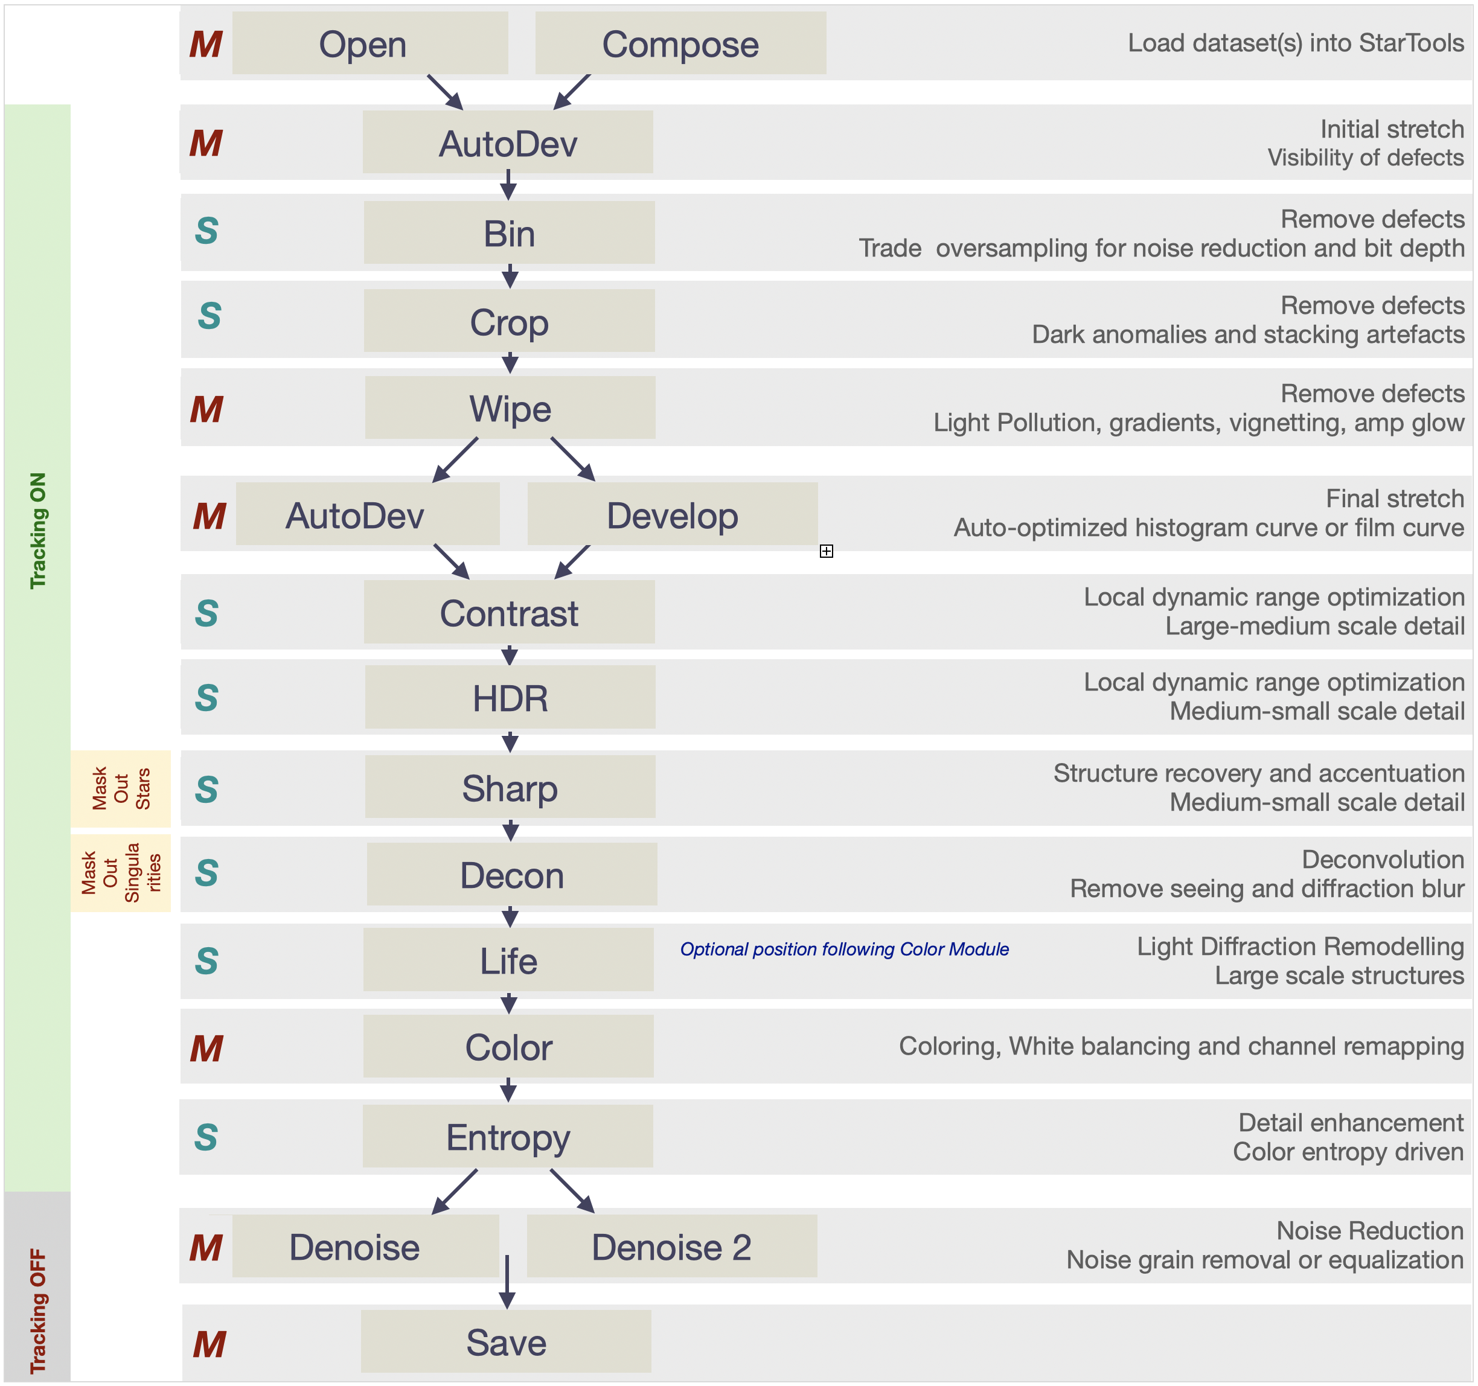
- Mandatory masks are shown. Sharp will require an inverse star mask. Decon module requires masking out singularities only.

Advanced Workflow Diagram
Advanced workflow with mandatory (M) and suggested (S) modules to the left and optional modules to the right.
- StarTools workflow allows some flexibility. The diagram is meant to provide a starting point for the use of optional modules
- Please check the 'Special Techniques' sections in the 'User Notes' chapter to find more hints to explore the versatile use of modules in different slots.
- Within 'Tracking On' and 'Tracking Off' blocks, StarTools allows the execution of steps in a different order
- Loading, stretching and noise reduction steps offer two options each.
- Mandatory masks are shown. Sharp and Flux will require an inverse star mask. Decon module requires masking out singularities only. Shrink, Repair and Synth work on a mask including stars only.
- Masks may be used optionally in some other modules including Wipe, Life, Color, Filter, Layer, Heal
- Layer and Flux modules are not shown. These may be used in many different locations depending on purpose

